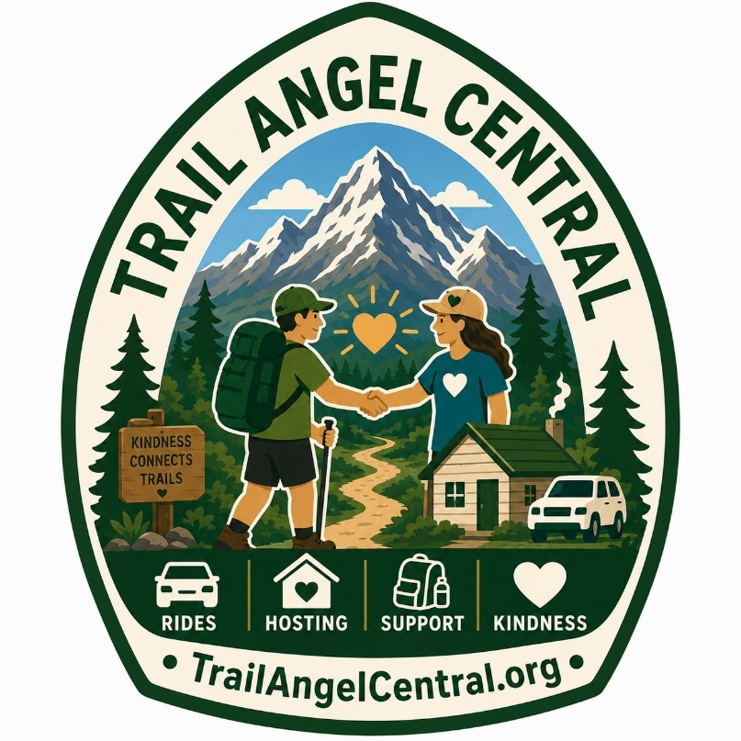

Trail Angel Central
Best Practices Guide
Version 1.0 – July 2026

Visit: www.TrailAngelCentral.org
Email: TrailAngelCentral@gmail.com

This document is a collaborative effort from the Trail Angel Central (TAC) annual gathering and other contributing Trail Angel members. We encourage you to help us continue to refine and expand this guide into the future and join the Trail Angel Central community to mentor and foster the Trail Angel communities worldwide.
Trail Angel Best Practices Guide

What is a Trail Angel, Trail Magic, Water Angel, and Trail Business?
There are different definitions of a trail angel. Often, it is simply a person or group who provides trail magic or wants to assist hikers with some type of resource or service with motives of kindness and generosity and not profit. Some angels are highly coordinated and participate in a network of other angels from their area and neighboring regions. Many angels respond to online requests for assistance. Then there are angels who will see hikers in town or on the road and prefer to offer spontaneous assistance.

Some angels provide transportation usually to or from trailheads but also to other locations. These may be coordinated with the hiker ahead of time or are spur-of-the moment rides for a hiker hitching a ride from the side of a road.

Angels may provide lodging that may include laundry, showers, or meals. Lodging could include pitching a tent in a back yard but may also include bunks, spare beds, or bedrooms in a home or outbuilding. Many angels will offer hikers the options of showers and laundry. Some angels will even provide home cooked meals for the hikers or allow hikers access to a kitchen to cook their own means.

Some angels will also allow hikers to mail resupply packages to their home or provide information to hikers on resources within their community. Trail angels often offer critical “local” information and logistics that are incredible valuable to the hikers not familiar with local resources, favorite destinations or traditions.

While money is not a motive for most angels, some may provide a donation box for hikers who want to contribute something to their host. This is how some hikers enjoy expressing gratitude for the hosts’ kindness and generosity. Donations are optional and often given anonymously.

Trail magic is usually an event where free food, drinks, or services are offered at a location where you typically would not expect them. Occasionally, this magic is simply provided in a hiker box at a trail location but is often done in person. Food and drinks may include cooked meals (such as on-site barbeques), cold fresh fruit and vegetables, which are hard to come by on the trail, and snacks and resupply items, such as trail bars. Some magicians are mobile, traveling to various spots along a trail where they station themselves and offer their kindness to hikers.

A water angel is a person who provides and maintains water caches along the trail.

Trail businesses are legitimate, but they are not trail angels. They are someone who offers services to a hiker in exchange for payment. These may include transportation, lodging, or food.

Best Practices
For Trail Magic
- Are you offering trail magic? Not all hikers are interested in magic. Ask if they are interested. Don’t be offended if they don’t.
- Get information from land agencies for how and where to provide services for hikers.
- Be thoughtful and respectful when doing trail magic.
  - Leaving food or items that create trash or attract wildlife can be problematic. Leave no trace! Pack it out. Don’t leave food, drinks, trash, coolers, or scented items (such as hand soap) without solid protection against animals. If items are left, monitor the site and clean up after yourself.
  - Be cognizant if you’re in an area where a lot of day hikers park. This may not be a great place to offer trail magic if you want to focus on section- and thru-hikers.
- Don’t provide trail magic next to or near businesses, competing with their business. Small communities often rely of hikers’ patronage for their survival.
- Avoid playing loud music.
- Be mindful of advertising trail magic too far in advance, if at all. It can take away the surprise and cause a bubble of hikers if they are anticipating it.
- Keep vegetarian, vegan, dairy-free, and gluten-free hikers in mind. Food can be prepared beforehand.
- Choose a location that doesn’t obstruct the trail. To find a good place, simply google or AI asking, “Where is the PCT bubble and give me 3 car/van/truck accessible locations near X location?”
- Coordinate with other trail angels; communicate with your local group, team up to work together! This will help avoiding some issues with larger trail magic events with thoughtful execution or competing trail magic offerings.
- If you want to provide water cache, something hikers appreciate, secure the water bottles correctly so that they don’t blow away/get carried away. Monitor, maintain, and clean up your contributions. Coordination and communication of water caches with hikers is an important part of providing reliable water cached sources. See info on water angels.
- Whenever you’re at a trailhead, bring bags to pack out trash that may have been left behind.
- Consider drafting a Leave No Trace-style document for hikers and for trail angels.
- Provide a portable handwashing station that uses soap to mitigate potential problems (such as norovirus spread). Hikers will appreciate the opportunity to wash their hands, something difficult to do on trail.

For Mobile Trail Angels
- Mobile trail angeling involves connecting along the trail/road crossings with a vehicle and providing trail magic in different locations that may be for hours or days long. Angels will typically bring food, chairs, handwashing stations, etc. with them to different points along the trail.
  - Provide a hand-washing station! Include hand soap and a large water container with a spigot or a spray bottle with diluted soap in water. Don’t forget paper towels to dry hands!
- Trail Angel Central could create a list of best locations where trail magic and angels could best offer services. Identify locations for good parking, camping, and trail magic sites. National forest lands have dispersed camping/parking for free within regulation, BLM sites.
- Provide proper trash receptacles.
- Consider burying used dishwashing water in a cathole to protect wildlife and leave no trace.
- Hikers appreciate foods high in calories and nutrition. This includes sugary and full-fat foods, or fresh fruit and veggies! Provide Gatorade with sugar, sodas, snacks (not just your typical hiker snack of granola bars or gummy bears), fresh fruit, watermelon slices, carrots, cuties, bananas, something cold, hummus, even chocolate milk!
- Choose a place with seating and where shade is available. Consider bringing chairs since most hikers don’t carry them.
- Optional items: first aid supplies, gear aid/repair, massage balls, duct tape, glues, small repair tools, sewing kits, tent repair tapes, etc.

For Hosting Hikers
- Avoid being overused. “No, thank you.” is a polite and complete sentence. Volunteers can be useful, but according to your risk tolerance.
- Understand hikers needs. Their needs are often simple. Ask hikers what they need. If they’re injured, have food allergies, etc. Be intentional about asking hikers if there are some special needs like medical, banking, communications, equipment or logistics they need help with that they might be shy to ask for.
- Establish good communications with hikers.
  - If you provide food, make it known up front and ask if they want to partake.
  - Be transparent about your donation or fee requests during your initial discussions. If you accept donations, consider offering electronic donation options. Many hikers don’t carry paper money! International hikers can’t use Venmo.
- Document rules for your operation; know your boundaries and clearly enforce them. Rules may include alcohol or drug use, quiet hours, laundry and shower policies, stay limits, etc. Don’t be afraid to ask/tell people to leave if they exhibit bad behavior.
  - Call other trail angels if you need help with problematic hikers; communicate about problematic hikers to other angels and neighboring trail communities.
- Feel free to have a hiker journal available for your guests to sign. It’s a great way to remember those you have helped.
- Provide town information (services, grocery stores, restaurants) or amenities you may provide (bicycles, laundry, etc.).
- If you’re able, offer hiker boxers (surplus supplies that hikers leave for other hikers) or hiker “loaner” clothes (clothes that hikers can use while doing laundry). These create a welcoming environment that is sustainable for angels and hikers.
- Be mindful of controversial conversation topics. Hikers may be from different countries and backgrounds and may not share your views and sense of humor!
- Consider car and homeowners insurance. Liability coverage might not cover accidents/events; be mindful of your risk tolerance and policy. An umbrella policy with a high limit might be good to have, especially if you charge a fee or are asking for donations.
- Let people know if they are in a safe space. (Women-offered lodging, LGBTQ allyship, observant of religious needs, etc.)
- Mentor new trail angels with your trail angel or hiker experience when possible. Help all trail angels feel confident and safe.
  - New hosts may not be familiar with the basic hikers’ needs of laundry, wi-fi, resupply at stores, power charging stations, and flat spots to pitch a tent. For example, many hikers do not carry towels. Towels and “loaner” clothing for showers/to wear while doing laundry are often appreciated.
- Be ready to handle an urgent fire or other immediate transport need where collaboration of trail angel resources may be needed to assist hikers.
  - It is greatly beneficial if trail angels have medical and fire, USFS or park contacts and numbers ready if a situation requires it.

For Transportation, Logistics, and Shuttles
- Do not commit to a ride without first discussing and agreeing to any donation or compensation. Both the hiker and driver need to be transparent and clear about their expectations at the start not at the end of the ride. (Requesting a payment after the ride has been provided is trail piracy, not trail angeling!)
- Picking up a hiker? Have a spray bottle and Dr. Bronner’s hand soap available for hikers to wash their hands before they enter your vehicle. Norovirus is not killed by hand sanitizer (only by soap handwashing or bleach cleaners).
- At the pick-up, ask the hiker to update or delete their online post requesting a ride (If they did that). Deleting removes a lot of extra FB requests that must be scrolled through by hikers and angels.
- Coordinate with other trail angels for transportation and hosting combinations. This is especially important if the hiker needs to skip a section for personal reasons.
- Let hikers know where to put their packs (truck bed, backseat, next to them, etc.) Consider exiting your vehicle when hikers are storing their backpacks. For example, some hikers are wary of placing their backpacks in the trunk of a car when the driver is sitting behind the wheel of the car. (A driver with ill intent may leave before hikers enter a car.)
- Don’t let small kids in your car without car seats and a parent or guardian.
- Follow road safety laws and don’t expose yourself to liability because a hiker is in a hurry. Riders are required to wear a seatbelt in many if not all states and the driver could be ticketed. Check into ride share insurance necessities to cover yourself in the unfortunate event of an accident. The hiker may not come after you, but their insurance may well.

For Water Angels
- Water Angels are trail volunteers who continually monitor water caches and resupply critical water caching resources for hikers.
- It is important that water angels be aware of their water caches inventory to support larger clusters of hikers.
- Using FarOut and other social media, especially Facebook groups focused on water caches, will allow good collaboration as to when to refill critical water caches.
- Having a dependable group of folks who maintain a water cache has made water caches on the PCT fairly reliable and predictable for hikers.
- Water angels can review, monitor and update information on the FarOut and other apps to help communicate this critical support to hikers.
- Water angels make the trail more accessible to many who could not physically do a 30-50-mile water carry, which would be required without these critical water caches.
- Hikers still need to be properly informed of water cache resources and share water with others when necessary.

For Hiker Boxes
Hikers’ boxes are a unique hiker thru trail invention that allows hikers, and others, to share extra or no longer needed food, equipment and resources to other hikers. These hiker boxes often exist in stores, post offices, hotels, and trail angel homes where hikers often stay. They could also exist in your vehicle if offering rides or doing trail magic. They are most commonly used to share extra food when hikers resupply and acquire too much to carry until the next resupply.

As a trail angel, you can supplement these boxes with a few other items you purchase that are very valuable to hikers during resupply.
- Extra Zip Lock bags of various sizes
- Glues (super glue, shoe goo), duct tape , tent and pack repair tapes, small repair tools
- First aid kit and extra medical supplies, band-aids, etc.
- Hydration packets and small food items (including sauce packets, salt, etc.)
- Sewing kit to use or borrow
- Extra string or line
- Sharpie pens
- A laminated page that contains important local resource information that hikers can take a photo of
- Scissors
- Screw drivers
- Pen and paper

For Trail Maintenance
- Make sure you know the regulations of the areas in which you’re clearing trail.
- On the Appalachian Trail (AT), there are clubs along the trail that are responsible for maintaining sections.
- PCTA has volunteer opportunities. Visit Volunteer for more information.
- Certification and training for certain tools (crosscut, chainsaw, Sawyer certification) are helpful and often required. The US Forest Service offers programs, information, and trainings. PCTA and ATC both offer classes and training too.
- For untrained trail stewards, katanaboy saw, loppers, pruning shears, and leather gloves are essential items.
- Certification is recommended for leading groups for trail clearing. Practice and hone your skills; going out frequently is recommended.
Safety Issues and Solutions
For Trail Angels
- For trail angel communities who are coordinating efforts, consider background checks on participating trail angels.
- Call a non-emergency agency (if it’s not an emergency) to report truly problematic people and incidents so that there is a record in case future incidents occur. Please see Incident Reporting for information to provide.
- Feel out hikers before offering rides by asking questions. Feel free to retract ride offers if you are feeling uncomfortable.
- Trail Angel Central will be developing a support network to handle these difficult hiker / Trail Angel issues that require a 3rd party to record, report and manage an identified person (hiker or trail angel) and handle it in a safe manner maybe in a more anonymous way.

For Hikers
- Hikers should not feel intimidated to decline a ride if they are uncomfortable. Hikers may want to create code word or phrase within their group to let others know they are uncomfortable and should decline a ride. For example, the hiker speaking to a driver who appears drunk could turn to other hikers and ask if anyone forgot their trekking poles (their code for RUN!).
- Hikers should take a photo of the license plate before they get into the car and send it to a contact in the event they go missing!
- Have backup excuse to get out of car or stop before your real stop. You can tell them you are carsick, forgot something, or that a friend contacted you and is going to meet you where you are. If needed, you can let the driver know someone is tracking your location at all times.
- Hikers, try to look more presentable if you want to ride. Hitch princesses are real!
- Only hitch in areas where you are not endangering drivers to stop in unsafe locations. Carefully select your hitch locations.

Incident Reporting
First and foremost, please call 911 on your phone (the universal emergency telephone number in the United States and Canada, connecting callers directly to police, fire, and medical dispatchers). They can help sooner. Secondly, further report to the Trail Agency (listed below) where you are hiking; it is highly appreciated by them. Per TAC conversations with these trail agencies, they are familiar with and can coordinate across surrounding areas of the trail with various other agencies that are needed.

Please provide the suggested type of information needed to accurately document resource related incidents. Information may be provided to our email or used as an optional template as an attachment. Use additional attachments (photos, maps, drawings, or additional information) if needed. Information may be shared with necessary individuals involved in the administration and management of the Pacific Crest Trail to mitigate issues.

Contact First and Last Name
Contact Phone Number
Contact Email
Occurrence Date
General Location of Resource Incident
- State
- County (if known)
- Public Land Name (if known)
  - National Forest? National Park? Bureau of Land Management? State Park? Other? If unknown, please add any information to the Detailed Description of the Location section below. (Example: Inyo National Forest, Yosemite National Park, Ridge Crest Field Office, Anza-Borrego Desert State Park.)
Detailed Description of the Location
- Please add narrative text, mile markers, trail intersections, GPS points, etc.
Type of Incident
- Trail Damage
- Trail Obstructions (downed trees, rocks, etc.)
- Natural Resource Concern
- Resource Vandalism
- Mountain Bike Use or Conflict
- ATV / OHV Use or Conflict
- Dumping
- PCT Access Issues (Unreported Closures / Detours)
- Aggressive Animal (Wild / Non-Domestic)
- Other (Explain)
Description of Resource Incident
- Please add attachments if needed.
May you be contacted for further information?

Complete incident reports at the trail organization level as well.
- Continental Divide Trail Coalition (CDTC): CDT adobe incident report form
- Pacific Crest Trail Association (PCTA) (submit the incident report via email including the above information): PCT Email Reporting Link,
- Appalachian Trail Conservancy (AT): AT Online Reporting Form

Connecting Trail Angels with Hikers
Many trail town resupply locations offer group sites and information on platforms such as Facebook and others to help connect hikers with other hikers, and to trail angels and resources. See Trail Angel Central’s PCT Angels for a list of PCT general pages, class year pages, and location-specific pages.

Alternatives to Facebook
Not all hikers use Facebook. Many international hikers do not use Facebook. Following are tips on how trail angels can connect with hikers.
- Create a FarOut account and post in your area or road crossing or town. This may include what you are offering, where you will be, and when you are available. Understand that FarOut posts tend to be pushed down by newer comments continuously.
- Create a laminated list of local trail angels to post on community boards or at the trailhead. If you are worried about safety, get a burner number or Google Voice number to use solely for trail angeling communications. The PCTA recommends against this, but it can be helpful to hikers.

Best Practices for Trail Town Angels Facebook Groups
- For those trail towns with Facebook trail angel pages, and that have posts with important general information (such as trail angel names and contact information, or resource guides), group administrators can keep a post at the top of the group by clicking the three dots (…) on the post and selecting “Pin to Featured” (formerly “Pin to Top” or “Mark as Announcement”). This makes the post permanently visible at the top of the feed until it is unpinned or replaced.
  - This is a great way for hikers to connect directly with trail angels vs. creating a general post wand waiting for a trail angel to read a post and respond.
  - Coordinate with and get trail angels to opt in to sharing their names and contact information.
  - Angels should ask hikers to edit their posts when arrangement have been made and confirmed, indicating that they have a confirmed ride or lodging.
  - Hikers should not accept another ride while they wait for their accepted ride.
  - For angels coordinating rides with hikers, provide details of their vehicle (color, make, model) so hikers will know who to accept a ride from, so angels’ efforts aren’t wasted.
- Facebook group angels can provide dispatch requests to other trail angels that may be able to help. Creating a designated moderators/monitors of Facebook groups can communicate and help dispatch among the group and ask who’s available to take the ride.
- Create a local Google sheet and invite angels to join. They can list their names, contact information, location, availability, and how they are willing to support hikers.

How can Facebook group trail angels better meet and organize?
- Plan pre- and/or post-season “meet and greet” events for local trail angels to network with each other. Include neighboring trail town so angels can coordinate with each other as needed. Don’t forget to collect contact information!
- Create group chats for local trail angels that allow others to know who’s available and when.
- Coordinate community events, such as hikes or trail stewardships days, community education presentations about hikers and trail angels, so that community members will be more aware of hikers and their local trails, which in turn may incentivize more community members to participate as trail angels.

How to use FarOut and other apps effectively
- For those trail angels who would want to post their name and contact information, include your availability (including months, days, and times as appropriate) and what you are offering when you post your information.
- Post comments on trailheads and town waypoints.
- Update your comment for each year or more often as needed as posts drop off quickly to bottom with FarOut

